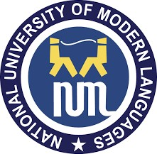
National University of Modern Language
Department of Software Engineering
Lab: # 02
Presented to: Ms. Rubab Mushtaq
Presented by: Uzma Mumtaz
Due Date: 28-Sep-2026
Roll No: I-SE2254426

Subject: Opearting System

Lab # 2
Task # 1
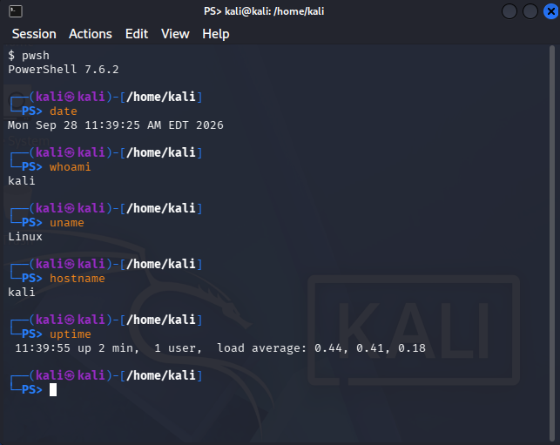

Task # 2
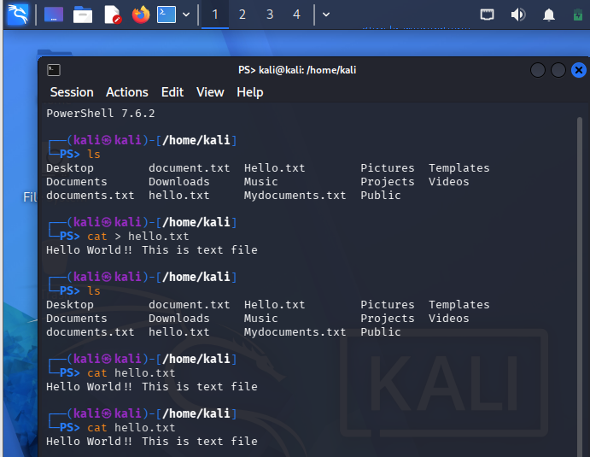

Task # 3
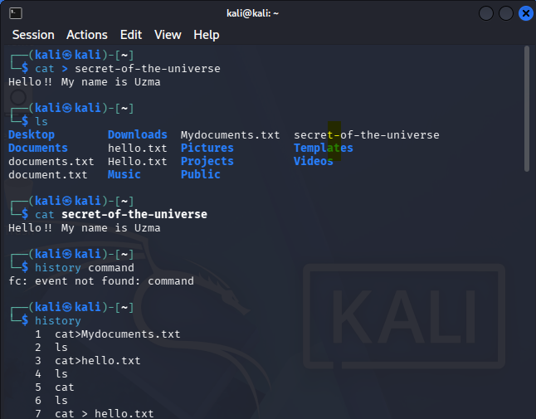
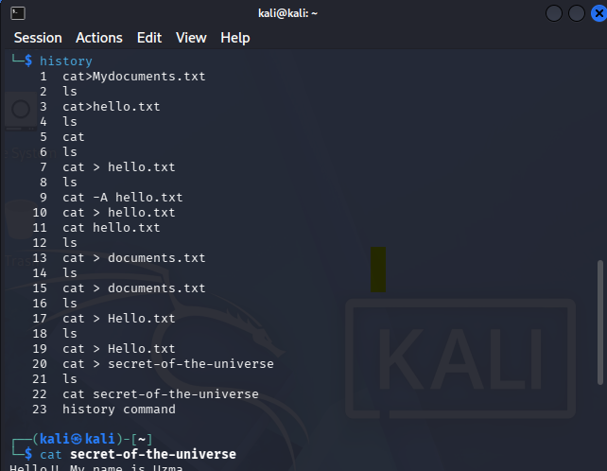

Task # 4
